**Lab 2_final**

1. Write a Java program to find the value of specified expression

a. (211 + 0) / 3

b. (true || false) && false

c. -3 + 7* 5

**Expected Output**

a. 70

b. false

c. 32

Solution:

public class Solution {

public static void main(String[] args) {

int r1 = (211 + 0) / 3;

boolean r2 = (true || false)&&false;

int r3 = -3+7*5;

System.out.println("(211 + 0) / 3)-> " + r1);

System.out.println("(true || false)&&false-> " + r3);

System.out.println("-3+7*5-> " + r3);

}

}

2. Write a Java program to print numbers between 1 to 50 which are divisible by 4 , 5 and by both.

**Test Data**

**Divide by 4**

**4, 8,12,16,20,24,28,32,36,40,44,48  
Divide by 5  
5,10,15,20,25,30,35,40,45,50**

**Divide by both**

**20,40**

**Solution:**

**public class problem2 {**

public static void main(String args[]) {

System.out.println("\nDivided by 4: ");

for (int i=1; i<50; i++) {

if (i%4==0)

System.out.print(i +", ");

}

System.out.println("\n\nDivided by 5: ");

for (int i=1; i<50; i++) {

if (i%5==0) System.out.print(i +", ");

}

System.out.println("\n\nDivided by 4 & 5: ");

for (int i=1; i<50; i++) {

if (i%4==0 && i%5==0) System.out.print(i +", ");

}

System.out.println("\n");

}

}

**3. Write a Java program that keeps a number from the user and generates an integer between 0 and 6 and displays the name of the weekday. For this exercise you may import java.util.Scanner.**

**Test Data  
Input number:2   
Expected Output :  
Wednesday**

**Input Number: 8**

**Invalid**

Soultion:

import java.util.Scanner;

public class problem3 {

public static void main(String[] args)

{

Scanner in = new Scanner(System.in);

System.out.print("Input number: ");

int day = in.nextInt();

System.out.println(getDayName(day));

}

// Get the name for the Week

public static String getDayName(int day) {

String dayName = "";

switch (day) {

case 0: dayName = "Monday"; break;

case 1: dayName = "Tuesday"; break;

case 2: dayName = "Wednesday"; break;

case 3: dayName = "Thursday"; break;

case 4: dayName = "Friday"; break;

case 5: dayName = "Saturday"; break;

case 6: dayName = "Sunday"; break;

default:dayName = "Invalid day range";

}

return dayName;

}

}

Javadoc_from Eclipse

To generate Java docs for your project you need to write the required information about the field, method or class as.

/**

   *

   * The method prints a simple message on the Console.

   *

*/

Then to generate the document follow the steps given below −

**Step 1** − Open eclipse, select the option Project →Generate Javadoc.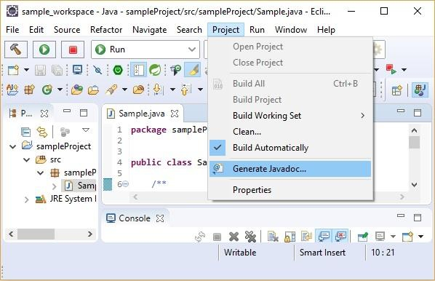

**Step 2** − Select the javadoc.exe file from the bin folder of java installation directory,  
select the destination folder for the generated java doc and select **Next.**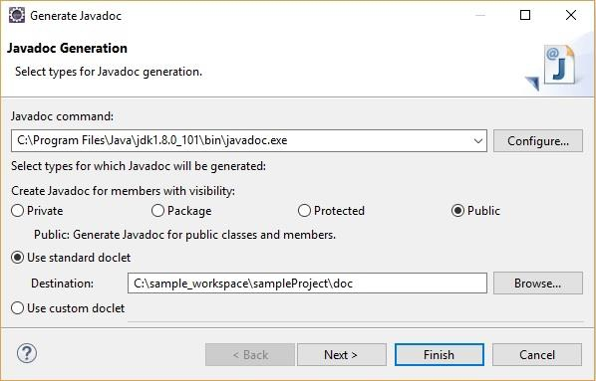

**Step 3** − Type the title of the documentation in the **Document title** and select the  
finish button.

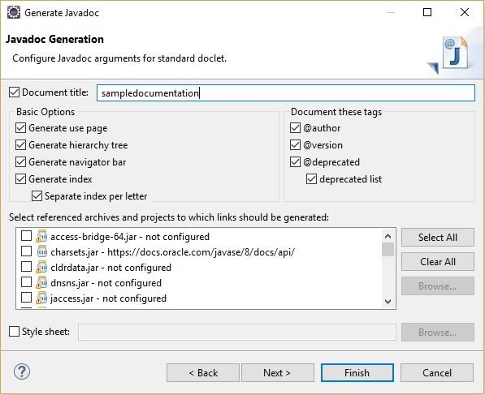

**Step 4** − Finally, you can observe the generated doc files in the generated folder.

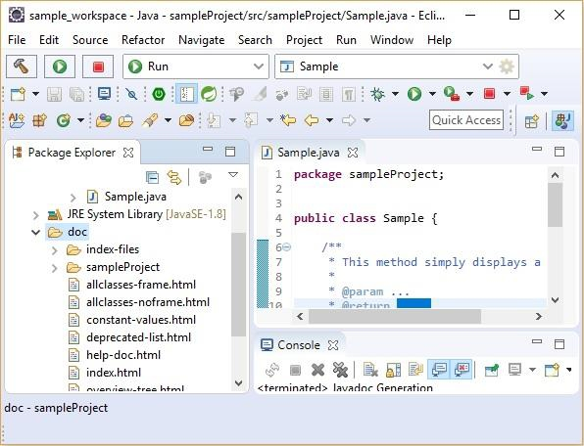

You can view the document by opening the **index.html** file with the browser.

